Forecasting McDonald’s Quarterly Revenue Using Time-Series Features and Gradient Boosting
Victoria Tiep (vat52), Michelle Li (mml243), Jenna Moon (jkm182)

- Project Definition:
Our goal is to forecast McDonald’s quarterly revenue to improve planning and decision making for the company. For a global corporation, the international sales are affected by seasonality, consumer demands, operating performances, and the economic environment that inevitably influences the revenue. Here, we’re trying to find the best variable(s) to build our model on in order to accurately predict revenue by combining historical financial data with features based on profitability and macroeconomic indicators. In short, our objective is to utilize a time series modeling approach that identifies patterns and provides estimates with predictable levels of error for future periods.
In current data management practices, when dealing with financial datasets, there will always be formatting issues. For example, mixing symbols such as “$” and “B”, which needs to be cleaned. If our data isn’t consistent, it’s inevitable that we run into problems with incorrect calculations and errors. Therefore, it was crucial that we did additional cleaning which accounted for trash values, took out data to scope our necessary information, extracted the year from data strings, and removed non numeric values.
The most helpful lecture slide was the ‘process for building the model’ slide, where the steps were advised and followed. For example, “import required Python libraries (e.g., pandas, numpy, sklearn) for data handling, modeling, and evaluation. Load Dataset: Load the data from a source (e.g., CSV file) into a DataFrame for further processing. Preprocess Data : Clean, transform, and prepare the data by handling missing values, encoding categorical variables, and scaling features. Split the Data: Divide the dataset into training and testing sets to build and evaluate the model. Train the Model : Fit the model using the training data to learn the relationship between input features and target. Evaluate the Model : Measure the model's performance on test data using metrics like R² score or Mean Squared Error (MSE)” (Guna).
We also made a few changes from our interim. Firstly, PostgreSQL was to be finalized and used for the database environment, but we ended up initializing a SQLite database directly within Google Colab and connected via Google Drive since the initial plan overcomplified our project and required a lot of external hosting while SQLite was a simpler solution and easier to set up. Also, we initially planned to use datasets on financial history, macroeconomic indicators (CPI, exchange rates) and commodity futures (beef, chicken, coffee, etc.), but we decided to change and use two financial history datasets in addition to the Big Mac Index dataset. This was because collecting, cleaning, and aggregating a large number of daily/monthly commodity futures and macroeconomic indicators into a clean quarterly features is a big ETL task and we found that focusing on the Big Mac Index gave us a more powerful and cleaner feature, which allowed us to focus time on modeling rather than extensive data engineering. Additionally, we were originally planning to have the ETL and cleaning be done using Python/Pandas script after database setup but we found that using SQL queries for tasks like joining is more efficient and cleaner. Lastly, we planned for our final model to be a Gradient Boosting Model like XGBoost but the final model ended up being a Gradient Boosting Regressor which was implemented using sklearn. This was because the standard Scikit-learn GBR is simpler to implement and requires fewer dependencies. It also works well for cross validation and hyperparameter tuning.
While we couldn’t find prior works related to forecasting quarterly revenue, there is a research proposal similar where a model forecasts human resources management using weather change models. While it doesn’t name a specific forecasting model type, it explicitly mentions “regression analysis is used to estimate the relations between variables” (Tahmasbi 2024). The research explores forecasting sales by incorporating non-financial, external variables, like weather conditions. This is related to our project because we aim to go beyond simple historical revenue trends. While they focus on human staffing, ours is forecasting for company planning, both of which is for the purpose of McDonald’s sales forecasting. However, our project differs ever so slightly because we implement more data rather than proposing just a conceptual framework.
- Introduction:
Our project focuses on building a more accurate system for forecasting McDonald’s quarterly revenue. The objective of this analysis is to create a robust quarterly revenue forecast for McDonald's to improve executive planning, resource allocation, and proactive management of investor expectations. Because traditional forecasting methods tend to rely mainly on historical values, they often miss key external signals that directly affect corporate performance. So, we made sure to account for seasonal demand patterns, economic cycles, and broader market forces that impact consumer behavior and sales. The model that we chose does just that as SARIMA was built to model both the seasonality and time dependent trends.
We gathered multiple datasets representing these seasonal demand patterns, internal metrics, and economic effects. We then proceeded to clean and process data using SQL to ensure that the information is consistent and removed missing and noise values. After cleaning, merge the datasets into a unified table to make it easier to analyze. This structure allowed us to build a dataframe to make a better forecasting pipeline.
For modeling, we first applied a SARIMA model to capture seasonality and time dependent trends. We then utilized engineered features into a Gradient Boosting model, allowing us to include operational factors and macroeconomic indicators, one being a signal based on the Big Mac Index dataset that we found. This combination provided a stronger predictive baseline and helped validate integrating external data.
We believe this project is important because a better and more reliable forecast supports better pricing, budgeting and planning for a company that encompasses millions of consumers. McDonald’s is a fast food chain that many college students can rely on as a budget meal. It’s affordable and an accessible food option, and better forecasting supports decisions that affect financial stability for the company. By including the operational factors and macroeconomic trends, we can get a more accurate prediction model.

- Methodology:

Database Component:
Our goal was to initialize a SQLite database environment within our Google Colab (which was pushed into Github) and populate it with three CSV files in order to make the data accessible via SQL for cleaning and modification. We connected the colab environment to Google Drive to make sure that the database file is accessible and not restricted to one local path, this way the entire group could run it. We then imported our libraries needed to manipulate our data and databases. We created a database file, mcdonalds_finance.db, along with the run_sql function from our lab, which was then used to execute our SQL commands. We then performed the extract, transform, and load (ETL) steps for each of the three csv files we uploaded by reading our csv files into temporary datagrams, which were then loaded into the SQLite database to create a table for each. To verify our work, we then loaded them in with a SELECT statement. 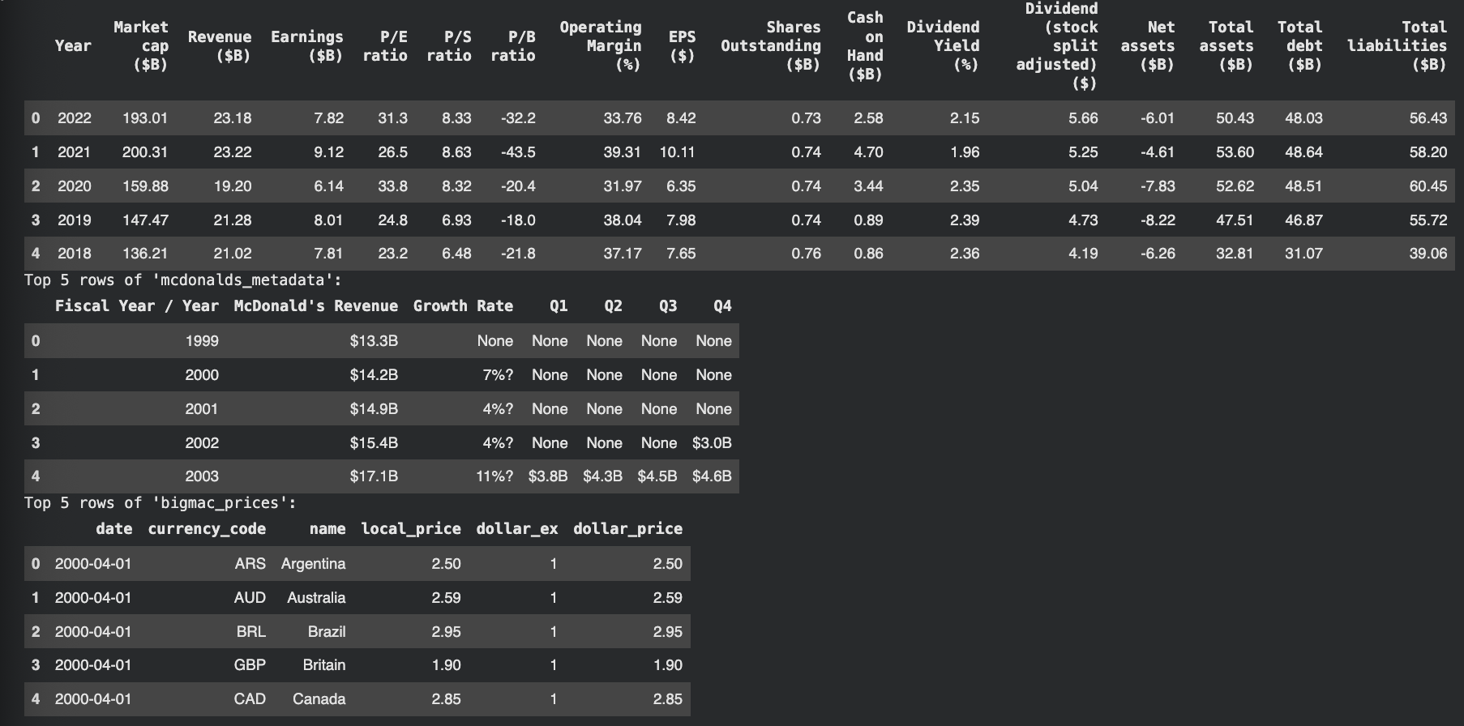
For our Big Mac data, we needed to standardize it so that merging it with our other data would be more efficient. The issue we ran into was that there were multiple pieces of data within the same year, which would then complicate our data when it came time to merge all three tables. To fix this, we started off by using DROP TABLE so that when we inevitably ran the code multiple times, it would delete any old version of the table. When then used CREATE TABLE in order to create a table that would also filter our data to keep only United States data, as the raw data included data from many other countries’, and we wanted to focus on the US. We also extracted the year from the Date column, as the original data contained a full data string, which wouldn’t have worked for merging. To account of the multiple records per year, we aggregated the data by using GROUP BY year and the AVG() function to calculate a single representative price for each year. We finally verified what we had using SELECT to ensure that we had a successful transformation so that the data would be ready for the main join.
For our merging process, we performed an extract, transform and load process using SQL to join all three data sources into one table, making sure that all our data is cleaned and standardized for analysis. We started off by dropping the table with the DROP TABLE IF EXISTS merged_table command so that we could start with a clean slate if we ran the code multiple times. We then created a table using the CREATE TABLE IF NOT EXISTS merged_table AS SELECT... statement, which then uses LEFT JOIN operations to combine the three tables based on the common Year column. For cleaning, we transformed the string values into REAL data types. For example, columns like McDonald's revenue, and growth rate, and the quarterly columns were cleaned to get rid of non-numeric values, and transformed them into Billions, so that when we compare them to our Revenue columns, they’d be in the same units. We then also used data type conversion to make them mathematically usable. We also filtered Year to not include 2002 since there was data missing for that year. We also verified that everything was correct via a select statement.
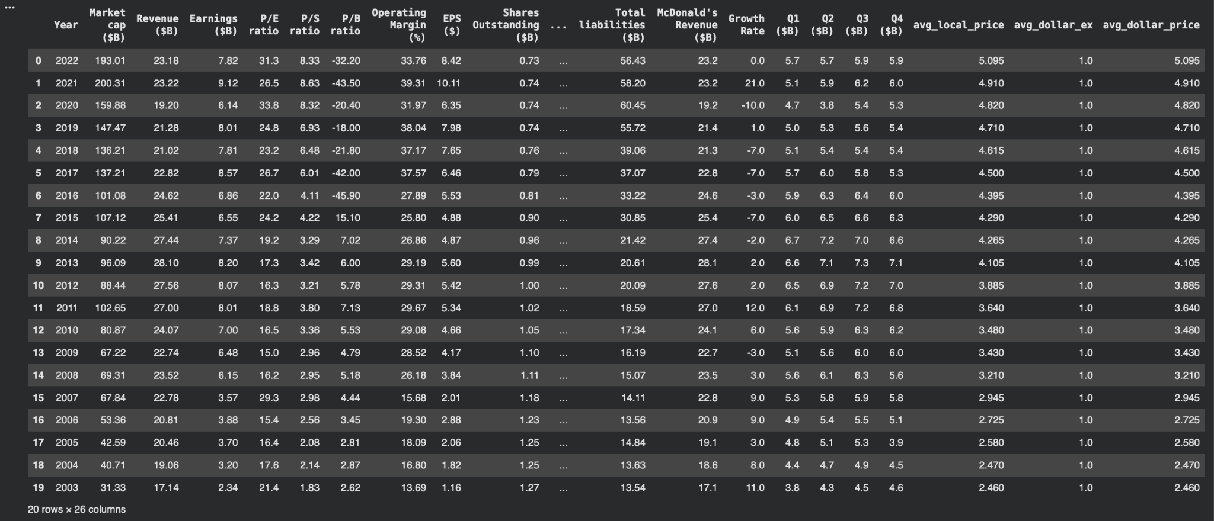
Finally, we took our processed and cleaned data and put it into a csv file, as well as in its own dataframe so that it could be used for our next steps. We did this with a SELECT and a pandas read function to save the table and load it into a pandas dataframe.

Data Science Component:
We created a time series visualization of quarterly revenue to assess trend strength, fluctuations, and seasonal cycles. This revealed a steady rise from 2004 through a peak near 2013, followed by a decline through 2017, a sharp drop in early 2020 related to pandemic disruption, and a recovery with stable revenue levels from 2021 onward.
We generated forecasting features based on domain reasoning and statistical dependencies. Revenue_Lag_1Q was introduced to reflect short term momentum. Revenue_Lag_4Q captured annual seasonality and was expected to be the strongest predictor. We calculated EPS_Rolling_Avg_4Q to smooth noise and provide a consistent indicator of profitability performance over a one year window.
We also engineered a novel macroeconomic feature. BigMacPrice_Vol_4Q measures the four quarter rolling standard deviation of the Big Mac Dollar Price. The hypothesis is that a higher degree of global price volatility signals exchange rate instability and economic uncertainty, which may influence McDonald’s international revenue when converted to USD.
We analyzed correlations to validate feature strength. Revenue_Lag_1Q had a correlation of 0.83 with the target, and Revenue_Lag_4Q had a correlation of 0.80. EPS and operating margin showed strong associations with each other. BigMacPrice_Vol_4Q had a weaker positive relationship but supported the hypothesis that volatility carries predictive signals. Histogram analysis showed the volatility feature was heavily right skewed and there were few extreme events, reinforcing that volatility is an intermittent but meaningful factor.
These results confirmed that lagged and profitability features carry the strongest predictive power, while macroeconomic volatility contributes as a secondary influence.

Machine Learning Component:
We used a Gradient Boosting Regressor for the forecasting model. Quarterly revenue values were converted from strings to numeric using a custom cleaning function. The data was reshaped from wide format to long using a melt operation and indexed chronologically using year and quarter.
Lag features were created using shift and rolling calculations. Revenue_Lag_1Q and Revenue_Lag_4Q captured short term and seasonal momentum. EPS_Rolling_Avg_4Q represented sustained profitability across the previous four quarters. BigMacPrice_Vol_4Q measured pricing instability through a rolling standard deviation.
The dataset was split chronologically with 72 observations used for training and validation, and the most recent 4 quarters used as a test set. The model was trained using tuned hyperparameters and evaluated using root mean squared error and mean absolute error.
The model achieved an average forecasting error of 277.9 million dollars and an average magnitude of error of 202.8 million. Considering typical quarterly revenue near 6 billion dollars, the average error remained under 5 percent. Historical back testing yielded higher variability which reflected changing market conditions but demonstrated stability in recent periods.
Feature importance confirmed the dominance of lagged revenue features, accounting for more than 80 percent of predictive influence. EPS_Rolling_Avg_4Q ranked third, confirming profitability as a key factor. BigMacPrice_Vol_4Q ranked fourth, showing that pricing volatility carried measurable forecast value.
We had hyperparameters for the gradient boosting regressor that yields the lowest error when tested chronologically. We initialize param_grid first which is a dictionary listing the specific values to test for three GBR hyperparameters. The three are n_estimators (the number of weak decision trees to build), learning_rate (weight of new trees added to the ensemble), and max_depth (maximum depth of each individual decision tree). Since our data is a time series, simply shuffling it randomly would introduce data leakage and ruin validity of results. Tscv = TimeSeriesSplit(n_split=4) makes sure that the validation is performed chronologically.
The model is trained only on past data and validated on future data to simulate the historical forecast. The GridSearchCV object combines the GBR model, the param_grid, and the tscv strategy. At scoring=’neg_mean_squared_error’, we tell the search to evaluate performance using mean squared error and find the parameters that minimize it. At grid_search.fit(X_train_val, y_train_val) runs the 27 combinations, trains the GBR model 4 times for each, and calculates the average MSE across the 4 chronological validation folds. Overall from the tuning process, we learn that the settings in our initial model were already optimal among all 27 combinations tested and the model is not highly sensitive to these parameters within the tested range. We also learn that the best historical cross validation RMSE of 0,6050 in billions of dollars is the lowest average historical error found across all parameter combinations. It is very close to the average CV RMSE calculated in our previous run, which confirms that the historical performance of our model is stable and well-characterized by an error of approximately $600 million when forecasting historical quarters chronologically.
We implemented a Seasonal Autoregressive Integrated Moving Average (SARIMA) model as a statistical benchmark, defined by the order SARIMA(1, 1, 1) x (0, 1, 1, 4). This model relies only on the internal historical structure of the revenue series.The SARIMA model achieved a lower forecasting error than the GBR model on the 4-quarter test set:
Metric | SARIMA Result (Billions) | GBR Result (Billions) | Comparison
RMSE | 0.1870 | 0.2779 | SARIMA performs better on this test set
MAE | 0.1635 | 0.2028 | SARIMA performs better on this test set
This finding confirms that the SARIMA model sets a very high benchmark, proving that the internal historical structure of McDonald's revenue is currently the most reliable predictor of its future value for the final four quarters.

- Results:
We were able to successfully build and complete a forecasting system for McDonald’s quarterly revenue. Resulted in a merged dataset that combined revenue, profitability, and price index information. We visualized the target variable to confirm seasonal and structural patterns, and produced a correlation matrix that guided feature selection. The gradient boosting model delivered forecasting accuracy with under 5 percent error in the most recent quarters. Tables, correlation heatmaps, and time series plots illustrate the findings and support the structure of the model.

SARIMA MODEL:
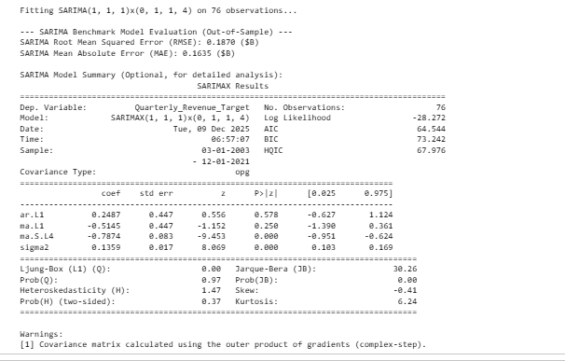

The result of the merged datasets, cleaned and easier for creating one dataframe:
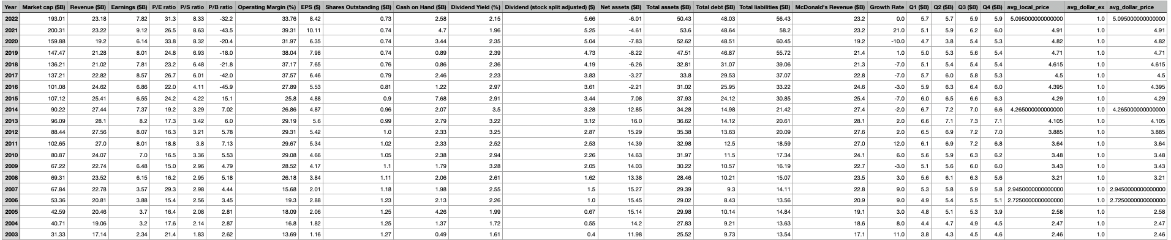
In order to select which columns to use for our SARIMA, we used a correlation matrix:
- 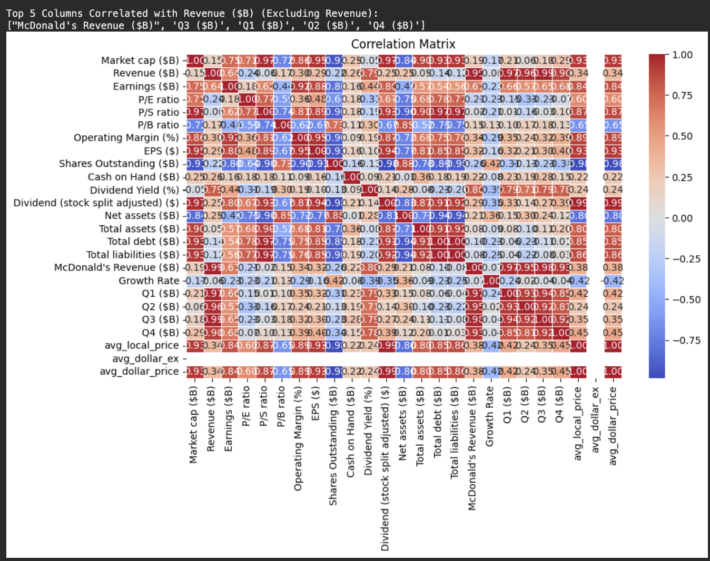
- Strategic Implications and Recommendations:
The high accuracy and stability of the Gradient Boosting Regressor model allowed McDonald's to move beyond simple historical tracking and into proactive strategic planning. The average forecast error of under 5% on a $6 billion base provides the confidence necessary for management to set precise investor expectations and optimize resource allocation for marketing and capital expenditures. Furthermore, the feature importance results directly inform strategy: the high predictive value of EPS_Rolling_Avg_4Q confirms that sustaining profitability is a key precondition for predictable revenue. Finally, the measurable influence of BigMacPrice_Vol_4Q provides an actionable macro-economic signal, suggesting management should use global pricing stability as a risk indicator for international operations and currency hedging. Moving forward, given the SARIMA benchmark's superior short-term performance, we recommend McDonald's strategically blend the GBR's feature-driven insights with the SARIMA's raw predictive power to create the most robust and stable revenue forecast.
- Contributions:
Victoria: Worked on the machine learning and data science components, including the Gradient Boosting model training and evaluation. Took the responsibility to initiate meetings where we discussed individual progress and got together to collaborate. Found ideal data sets, and made sure that we wanted the ones we chose instead of sticking to the first ones found.
Michelle: Handled data collection and cleaning, ensuring the datasets were properly formatted, aligned, and ready for analysis and modeling. Worked on the slide presentation that showed our functionality of code.
Jenna: Focused on the SARIMA model, training and testing the baseline forecast and preparing outputs for comparison. Helped finalize the final report. Created all the necessary documentations. Pushed project into Github.
- References:
Github link:
https://github.com/mjenna/Data_Management_Mcdonalds

Prior related work:
Ehsan Tahmasbi. (2024). Presenting a sales forecast model for McDonald’s human resources management using weather change models. ResearchGate. https://doi.org/10.13140/RG.2.2.31381.95204
Lecture Slide 14.1 Prediction Model

